附件1
中原城市群城市环境发展研讨会录用论文目录

城市冠层与边界层研究进展及在城市规划、精细NWP中的应用
·····································································································苗世光，窦晶晶，郑祚芳等
污染气象条件PLAM指数方法及华北与中原地区PM2.5预测应用研究
···············································································王继志，杨元琴，张小曳
大气气溶胶后向散射系数与合肥地区温、湿和能见度的时空演变分析
············································································程 华，袁 松，王东勇等
关中地区旱涝演变规律和本世纪旱涝特点分析················雷向杰，李化龙，李红梅等
近十年安徽霾的天气学特征分析··································弓中强，魏凌翔，朱佳宁等
1980—2013年安徽霾天气的时空变化特征及成因分析······石春娥，邓学良，李元妮等
郑州市2012—2014年春节期间大气气溶胶污染物时空变化特征研究
················································································李尉卿，杜光俊，王 梦
郑州市大气环境中醛酮类化合物的污染特征及来源研究·······赵新娜，王玲玲，王维思
郑州市主要大气污染物变化规律分析····························王玲玲，邢梦琳，李 明等
基于决策树分类的雾霾遥感监测方法研究···············································田宏伟
城市施工工地周边颗粒污染物及其与气象条件关系分析····袁晓柯，经 涛，张志铭等
城市尺度的热环境变化分析········································马 林，田国行，何瑞珍等
城市河流河岸带的类型、干扰特征及恢复对策···········································郭二辉
近50a黄河流域二十四节气与农业生产关系的研究····································赵洪升
郑州绿地雨水资源有效利用途径研究····························雷雅凯，彭丹丹，张淑梅等
郑州航空港经济综合实验区物流枢纽规划现状分析与发展策略····················李怀强
中原城市群水资源承载力评价······························································胡彩虹
郑州城区大气CO₂浓度变化特征及影响因素分析·················师丽魁，娄运生，方文松
上海徐家汇和奉贤雾霾日数气候变化特征分析····················徐相明，顾品强，李 聪
AUSTAL2000模式污染物落地浓度预测的气象因素敏感性分析·······················汪小康
城市近地层风特征与污染系数分析·······························徐永清，张 弛，王庆祥等
基于激光云高仪的雾霾过程探测··································卜令兵，袁 静，高爱臻等
近43年西安地区雾、霾天气时空变化特征及成因分析·····孟小绒，杜萌萌，金丽娜等
太原城市化进程对边界层影响的数值模拟··························董春卿，郭媛媛，王 扬
我国东北地区一次秋冬季节重污染天气分析研究·············吕梦瑶，张恒德，张碧辉等
一次持续性雾霾天气过程的诊断分析··········································高媛媛，李 周
2013年1月郑州持续霾天气过程中的PM2.5的变化研究······························王 霄
CMIP3模式预估的21世纪东亚夏季降水年际变率变化过程··························富元海
北京城区近地面比湿和风场时空分布特征·························窦晶晶，王迎春，苗世光
北京城市气候图系统的初步建立··································贺晓冬，苗世光，窦晶晶等
北京地区空气质量指数时空分布特征及其与气象条件的关系
············································································张建忠，孙 瑾，王冠岚等
房山区强对流天气中自动站气象要素变化特征分析···································宋 歌
1951—2009年冬季北京极端低温事件变化分析·········································许国宇
CALPUFF模型在合肥地区大气环境容量测算中的应用研究····孙 维，陈 飞，王晖等
基于时间序列拟合的北京市AQI与气温关系剖析················马 盼，王式功，尚可政
莎车县1961—2010年气温、降水、日照气候变化特征····················王 东，徐相明
气象因子对巴旦木生育期影响分析························································徐祥明
“麦莎”台风对上海干旱的影响分析·······························郭 蓉，翁永元，雷小途
城市建筑的防雷设计·········································································毛润庆
河南省1961—2011年极端气温和极端气温事件的时空变化特征···················王 丽
河南省1961—2010年暴雨日数的时空分布特征········································张 远
Scale Invariance Analysis of the Decadal Wind Velocity in Henan Province···········王纪军
河南省冬季连续低温天气的时空变化特征·························王纪军，潘 攀，胡彩虹
河南夏季干旱气候特征分析···········································竹磊磊，常 军，张善强
郑州市大气混合层厚度的变化特征分析·························邓 伟，李凤秀，王贵军等
当前国内酸雨研究进展··············································邓 伟，李凤秀，王贵军等
华中地区空中水汽资源的输送和收支研究·························张 楠，王 霄，程家合
河南省空中水汽资源的来源、分布及收支······················刘艳华，李铁林，马鑫鑫等
郑州机场能见度变化特征及雾的成因分析···············································邵振平
驻马店市酸雨变化特征及影响因素分析讨论············································陈 松
发展低碳经济 降低污染 减缓雾霾天气的发生················李 戈，李 新，许婧博等
城市空气颗粒物浓度与环境因子相关性分析及其防治措施初探··········蒋庆瑞，赵 勇
濮阳市一次雷雨大风天气过程分析··············································李丽平，牛盼杰
城市化对濮阳雾霾及环境污染的影响和防御············································李汉浸
1954—2010年商丘降水变化趋势及突变分析············································张云霞
济源市能见度特征及其影响因素分析····························脱宇峰，潘 攀，张丽娟等
基于GIS的洛阳市高温灾害风险区划······················································马 进
城市文明建设与气象浅析···········································刘 瑞，任凤慈，李志勇等
2012年河南省中东部一次大雾成因分析··················································余倩花
近43a安阳市雾日和霾日时空特征分析···················································黄先成
探析气候条件对城市规划的影响研究·····················································李青吉
温县环城生态水系西渠湿地生态环境评估·································冯晓科，苗国柱

附件2
中原城市群城市环境发展研讨会
参会回执

姓名 | 单位 | 性别 | 民族 | 职称/职务 | 联系方式

附件3
乘车路线

1.郑州火车站乘坐95路直达黄河迎宾馆，乘出租车约41元。
2.郑州东站乘坐地铁1号线到紫荆山站,在紫荆山公园门口换乘962路直达黄河迎宾馆，乘出租车约55元。
3.郑州机场乘坐机场巴士1号线到民航大酒店，从民航大酒店到黄河迎宾馆建议乘出租车，约40元。
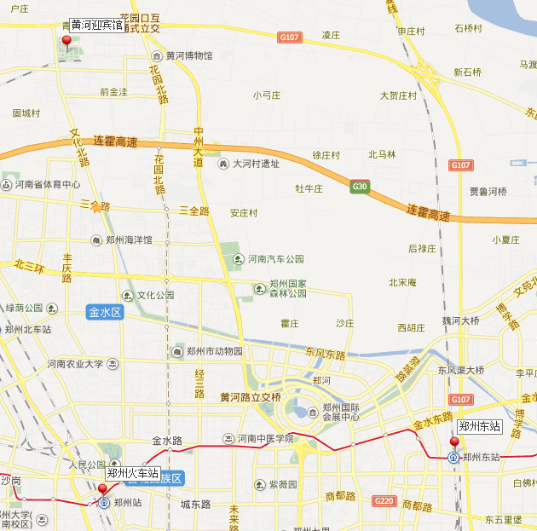

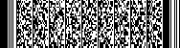

河南省科协办公室 2014年12月14日印

